Contact Roles

Exercise 1: Investigation

1. Use entityroleconstraints-config.xml to answer the following questions about contact role constraints.
   1. What is the only kind of subtype that can have the role "arbitrator"?
   2. Can a company be given the role "witness"?
   3. Can a doctor be given the role "witness"?
   4. How many role(s) can be assigned only to a contact of subtype "AutoTowingAgcy"?
2. Use entityroleconstraints-config.xml to answer the following questions about entity constraints.
   1. Can a claim have more than one:
      1. PrimaryDoctor?
      2. Assessor?
      3. Hospital?
      4. Nurse case manager?
      5. Pedestrian?
   2. For injury incidents, list one role where you are not limited to the number of times it can be used. Also, list one role that constrains you to selecting it no more than once.
   3. For the policy entity, which role must be held by exactly one contact?

**Exercise 2: Configuration**

Configure ClaimCenter to meet the following customer requirement from Acme Insurance.

**Requirement: Adding Interpreters to Negotiations**

Acme Insurance wants to be able to assign a contact with the role of interpreter to any given negotiation. The role should:

* Appear in the user interface as **Interpreter**.
* Be included in the **Vendor** category.
* Only be given to a contact of subtype **Person**.
* Can be owned only by **Negotiation** objects.

1. A negotiation is not required to have an interpreter, but it can have no more than one interpreter.
2. Configure ClaimCenter to create the interpreter role and ensure it meets the required business constraints.

**Test Case**

When you have completed your configuration, run the following test cases. Remember that the changes you make require a server restart:

1. Log on to ClaimCenter and navigate to a claim that has a negotiation. (Alternately, you can create a negotiation, by selecting Menu Actions 🡪 New Negotiation and providing a name, such as “Test Negotiation”.) Then, navigate to the **Parties Involved** screen.
2. Verify that you can:

* Add the role of interpreter to a contact of subtype person for the negotiation.
* See the interpreter contact when the contacts list view filter is set to **Vendors**.

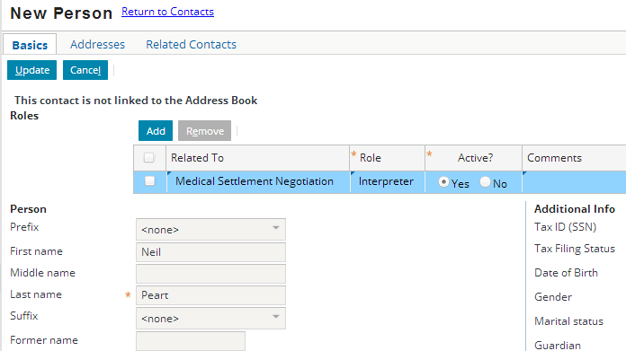

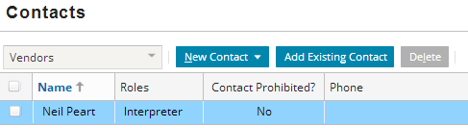

1. Verify that you cannot add the role of interpreter to:

* Something other than a negotiation.

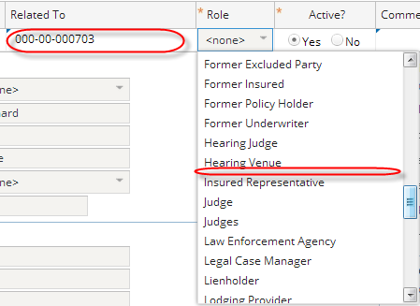

* Two contacts for the same negotiation.



* A non-person, such as a company.

